**Madanapalle institute of**

**Technology & Science**

**(ugc-autonomous)**

**Madanapalle**

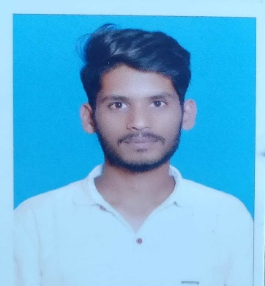

**Kolathuru YASWanth kumar**

Email: 21691A05P5@mits.ac.in

contact: (R): +91 06281718084

**CAREER OBJECTIVE**

* Determined Full Stack Web Developer dedicated to building efficient, user-centric applications. Seeking a position to leverage skills in both front-end development to drive innovative solutions and enhance user experiences.

**EDUCATION**

|  |  |  |  |  |
| --- | --- | --- | --- | --- |
| **Degree/ Examination** | **Year of Passing** | **School/Institute** | **Board/University** | **Percentage/Grade** |
| B.Tech  (Branch) | 2025 | Madanapalle  Institute of  Technology  and  Sciences,  Madanapalle | JNTUA | **8.63**  **(****as per 4 th sem)** |
| Intermediate/Class XII | **2021** | **APR Junior College,**  **Gyarampalle**  **80%** | Board of Intermediate Examination, Andhra Pradesh | 80% |
| Class X/S.S.C | 2019 | **ZP HighSchool,**  **Matlavaripalle** | Board of Secondary School Education,Andhra Pradesh | 92% |

**PROJECT WORK / TRAINING**

* **Internpe , LetsGrowMore , Oasis Infobyte , CodeClause , Elewayte Web development Internship**

**AREAS OF INTERESTS**

* Full Stack Development

**SOFTWARE SKILL SET**

* Languages : Python, C , C++ , Java , Html , CSS , JavaScript
* Operating System : Windows , Linux , Ubuntu
* Certifications : Coursera Google analytics , Data Engineering on Microsoft Azure

**ACADEMIC ACHIEVEMENTS & CO-CURRICULAR Activities**

* Participated In Smart India Hackathon 2023
* Participating in MITS Cisco Networking Academy – Batch-2 2023

**EXTRA CURRICULAR ACTIVITIES**

* Volleyball player

**PERSONAL DETAILS**

* Father’s Name : K Viswanatha
* Date of Birth : 13th March 2004
* Linguistic Proficiency : English,Telugu
* Address : Peddakurappalle(V),Ramasamudram(M),Chittoor district

**DECLARATION**

I hereby declare that the information furnished above is true to best of my knowledge.

Date: Signature

(K YASWANTH KUMAR)